Multi-Stage Water Purification System

Stage 1: Oxidation for Manganese Removal
Stage One removes manganese by first oxidizing the soluble (Mn(II)) form into insoluble manganese oxide (MnO₂) particles, which are then filtered out using either a Greensand filter or an aeration and filtration system. Aeration uses dissolved oxygen to convert Mn(II) to MnO₂, while Greensand filters use a manganese-coated media to catalyze the oxidation and filtration process. Both methods remove manganese to improve water taste and prevent staining.
How the process Work:
- Oxidation:
Dissolved manganese (Mn(II)) is converted into insoluble manganese dioxide (MnO₂).
- Aeration:
Air is introduced into the water to provide dissolved oxygen, which oxidizes Mn(II) into MnO2 particles.
- Greensand Filtration:
The water flows through a filter bed containing Greensand media, which has a manganese-oxide coating. This coated surface acts as a catalyst, promoting the oxidation of Mn(II) into MnO₂.
- Filtration:
The insoluble manganese dioxide particles are then trapped and removed by the filter media, which can be Greensand or other filter materials like sand.
- Backwashing:
The filter is periodically cleaned by reversing the water flow (backwashing) to remove the accumulated manganese oxides from the filter bed.
Purpose:
- Aesthetic Quality:
Removes dissolved manganese that causes black staining, bitter taste, and metallic odors in water.
- Health Considerations:
Addresses potential health concerns linked to high manganese exposure, although EPA guidelines are typically for aesthetics rather than direct toxicity at lower levels.
- Preventing Staining:
Eliminates manganese deposits that can cause black staining on fixtures and laundry.
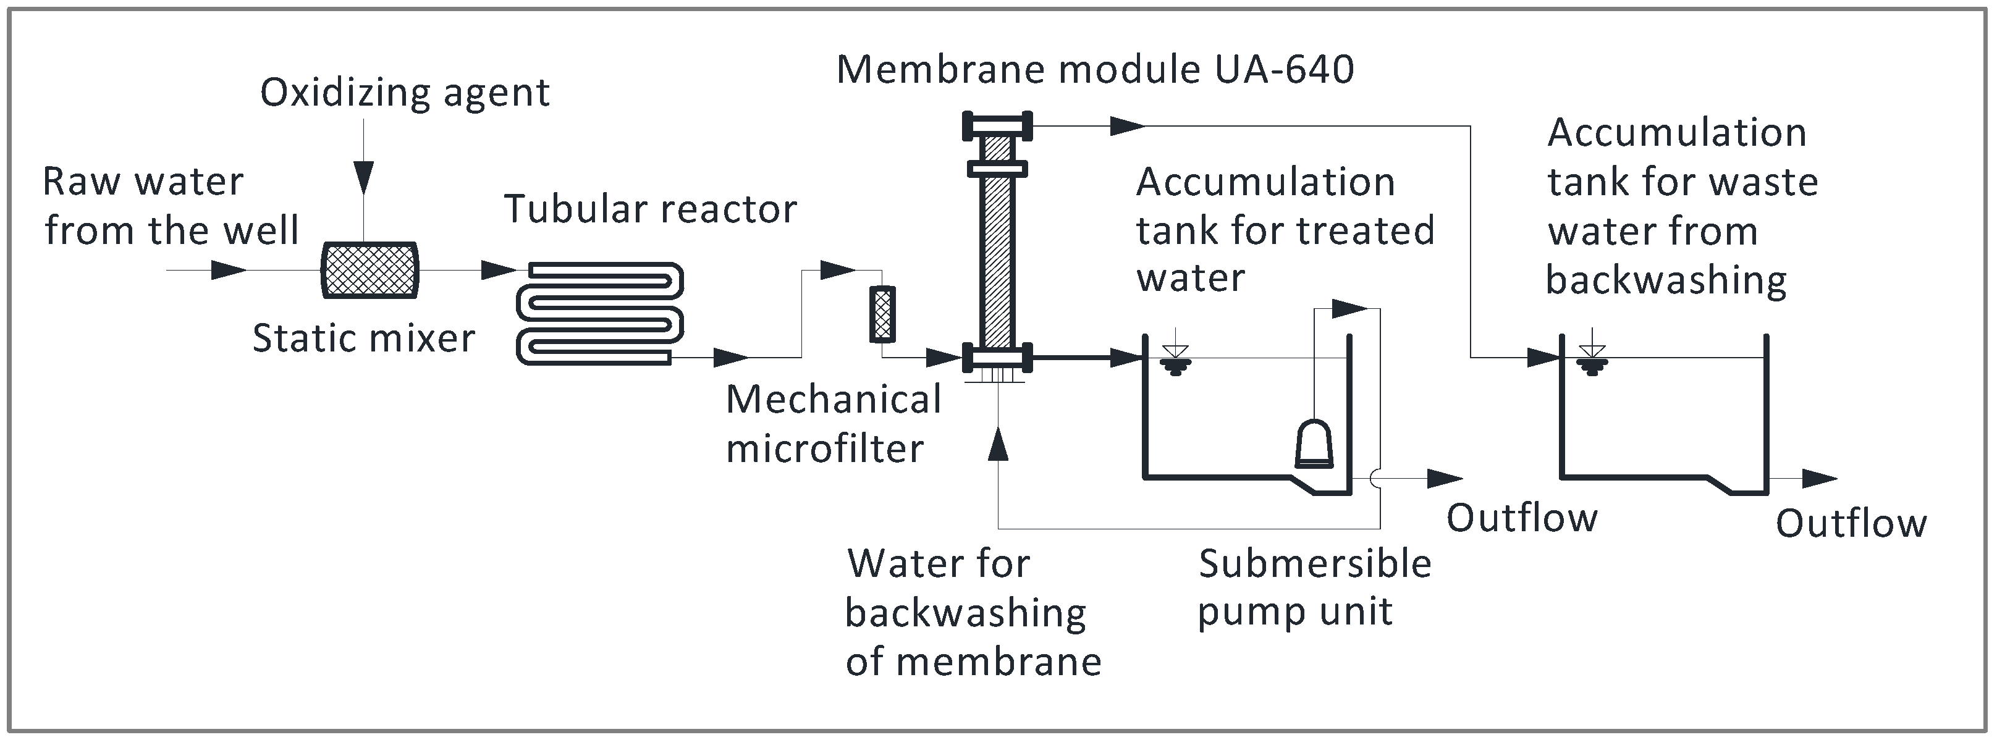
Figure 1:STAGE 1:OXIDATION FOR MANGANESE

Stage 2: Heavy Metal Adsorption and Chemical Reduction
In the advanced adsorption stage, heavy metals like lead (Pb) and mercury (Hg) are removed by activated carbon and KDF media. Activated carbon adsorbs these metals through strong physical and chemical interactions on its high-surface-area pores, while KDF acts as a redox medium. For mercury, KDF can convert toxic Hg²⁺ ions to elemental mercury (Hg⁰), which then adsorbs onto the carbon. For lead, both the carbon and KDF media can bind Pb²⁺ ions through complexation and ion exchange, though the specific reactions are complex and not represented by a single universal chemical equation.
Simplified Chemical Interactions:
- Mercury Removal (Simplified):
  - Reduction by KDF: Hg²⁺(aq) + 2e⁻ (from KDF) → Hg⁰(s)
  - Adsorption by Activated Carbon: Hg⁰(s) + C (activated carbon surface) → Hg-C (adsorbed mercury)
- Lead Removal (Simplified):
  - Complexation with Carbon: Pb²⁺(aq) + C-OH (carbon surface functional group) → Pb-OH-C (complex) + H⁺
  - Adsorption with KDF: The interaction is complex, involving redox reactions and ion exchange, where Pb²⁺ ions replace other ions on the KDF surface, or are oxidized and precipitate.
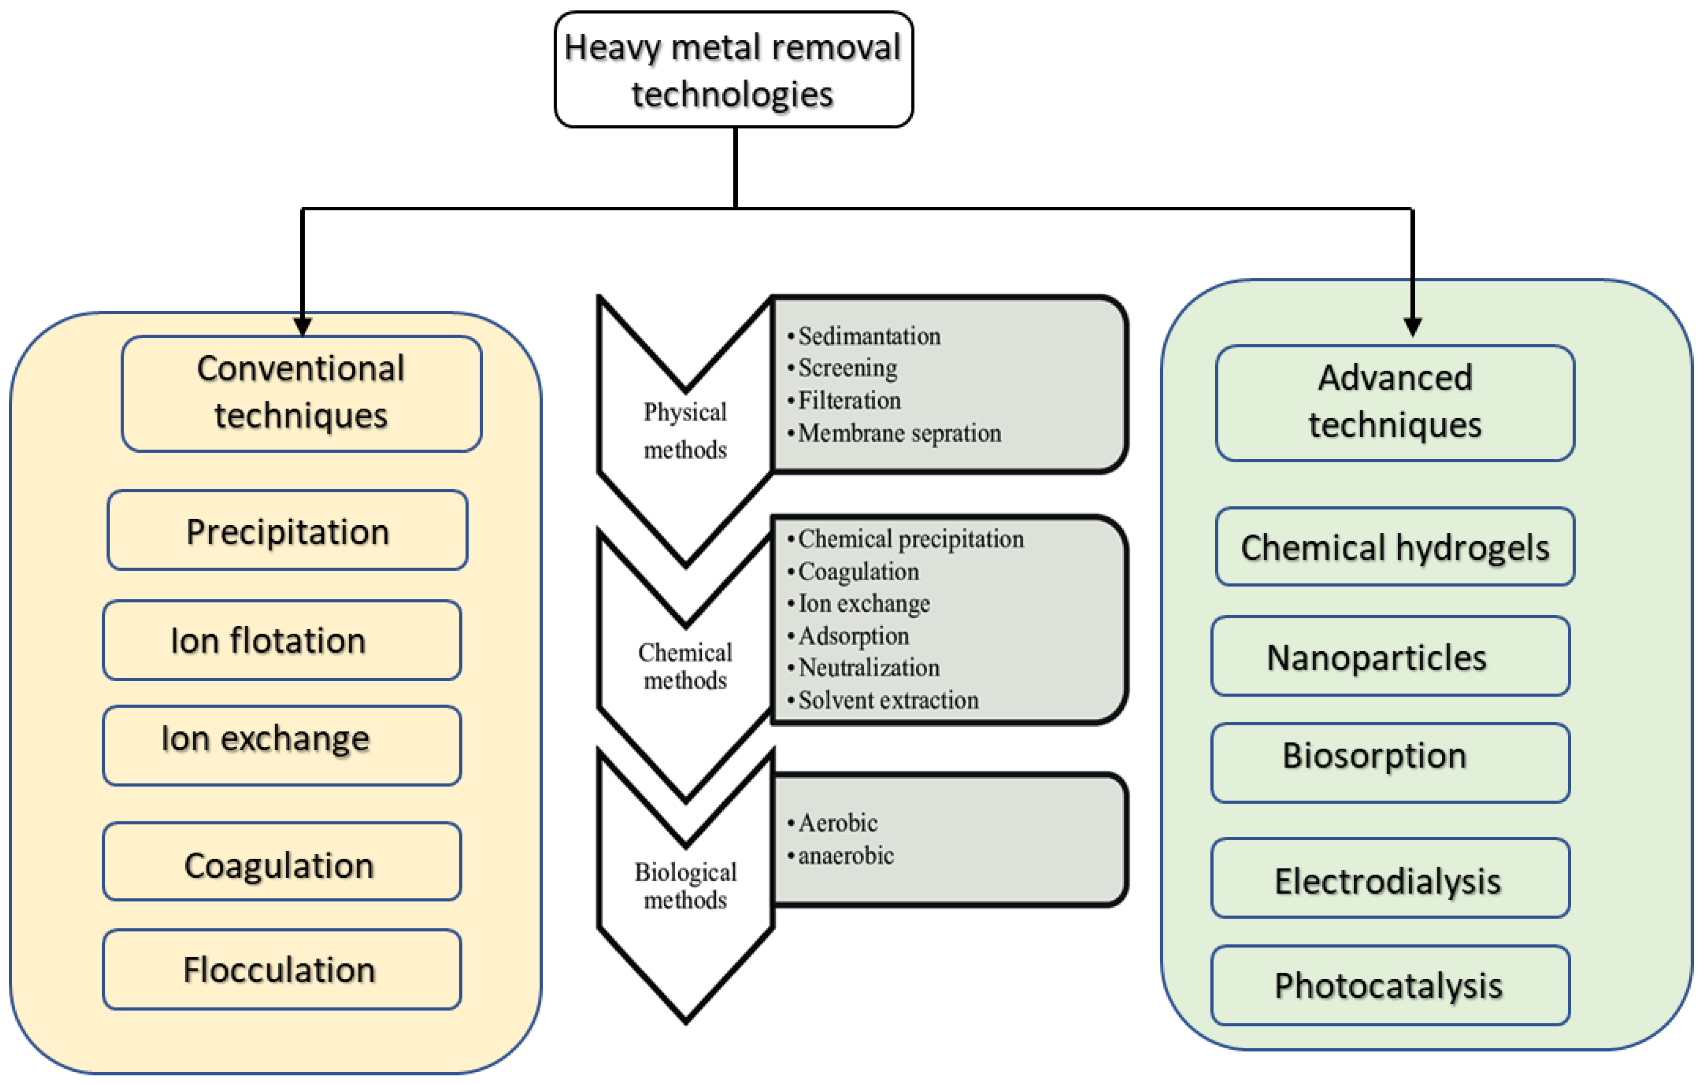
Figure 2:HEAVY METAL ADSORPTION

Stage 3: pH Balancing and Remineralization
Alkaline remineralization reintroduces vital minerals, particularly calcium and magnesium, to purified water, raising its pH and improving taste. A common method involves passing water over a bed of limestone (calcium carbonate) or dolomite (calcium magnesium carbonate), where dissolved minerals, such as calcium, magnesium, and bicarbonate, are slowly added to the water.
The Process:
Mineralization:
The water flows through a bed containing alkaline mineral-rich media, such as limestone (CaCO₃) or dolomite (CaMg(CO₃)₂).
Chemical Equations
The specific chemical equations depend on the mineral media used, but common examples include:
- Using Limestone (Calcium Carbonate - CaCO₃):
  - Water dissolves limestone over time:
CaCO₃(s) + H₂O(l) ⇌ Ca²⁺(aq) + HCO₃⁻(aq) + OH⁻(aq)
- Using Dolomite (Calcium Magnesium Carbonate - CaMg(CO₃)₂):
  - Dolomite dissolves, adding both calcium and magnesium:
CaMg(CO₃)₂(s) + 2H₂O(l) ⇌ Ca²⁺(aq) + Mg²⁺(aq) + 2HCO₃⁻(aq) + 2OH⁻(aq)
- Reactions with Dissolved CO₂ (often present):
  - The introduced bicarbonate ions react with dissolved carbon dioxide to help buffer the pH:
CO₂(aq) + OH⁻(aq) ⇌ HCO₃⁻(aq)
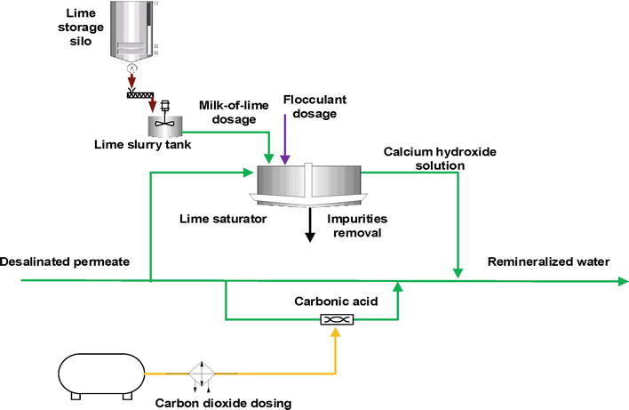
Figure 3:ALKALINE REMINERALIZATION
Smart Water Monitoring & Purification Device:
The system is designed to detect and purify five critical parameters:
pH, Lead (Pb), Mercury (Hg), Manganese (Mn), and Magnesium (Mg)
It integrates ESP32-S3 sensors for real-time data monitoring and uses multi-stage filtration for purification.
Major Filtration Stages in the Smart Water Purification Device
Stage | Filtration Process | Purpose / Target Pollutant | Description
Stage 1: Oxidation + Filtration | Greensand or Aeration | Manganese (Mn²⁺) | Oxidizes dissolved Mn²⁺ to insoluble MnO₂, filtered out easily.
Stage 2: Adsorption + Ion Exchange | Activated Carbon + Resin Filter | Lead (Pb²⁺), Mercury (Hg²⁺) | Heavy metal ions are trapped by carbon pores and exchanged with harmless ions like Na⁺ or H⁺.
Stage 3: pH Conditioning and Mineral Balance | Calcite Filter + Reverse Osmosis | pH and Magnesium (Mg²⁺) | Adjusts acidity/alkalinity and removes excess minerals for balanced water.
Pollutants and Their Removal Methods with Chemical Reactions
(a) pH – Hydrogen Ion Concentration
- Problem:
- pH measures hydrogen ion concentration in water:
- $\text{pH}=-{log⁡}_{10}[{\text{H}}^{+}]$
- Ideal drinking water pH: 6.5 – 8.5 (neutral to slightly alkaline)
Outside this range, water becomes corrosive (acidic) or scale-forming (alkaline).

Adjustment Reactions:
1. Making Water Alkaline (raising pH):
Neutralizes acidity by adding basic compounds such as lime (Ca(OH)₂) or soda ash (Na₂CO₃).
$${\text{H}}_{2}{\text{CO}}_{3}+{\text{Ca(OH)}}_{2}→{\text{CaCO}}_{3}↓+2{\text{H}}_{2}\text{O}$$
2. Making Water Acidic (lowering pH):
If pH is too high, acids like CO₂, H₂SO₄, or HCl are added carefully.
$${\text{CO}}_{2}+{\text{H}}_{2}\text{O}→{\text{H}}_{2}{\text{CO}}_{3}→{\text{H}}^{+}+{\text{HCO}}_{3}^{-}$$
3. Balancing to Neutral (7.0):
Automated pH sensor feedback (e.g., DFRobot pH Sensor V2, Gravity Analog pH Meter – available in Pakistan) adjusts chemical dosing dynamically.
(b) Lead (Pb²⁺)
Pollutant:
Lead ions originate from corroded pipes or industrial discharge — toxic to nervous system.
Removal Method:
Chemical precipitation & adsorption using lime softening, activated carbon, or ion exchange.
$${\text{Pb}}^{2+}+{\text{SO}}_{4}^{2-}→{\text{PbSO}}_{4}↓$$
or
$${\text{Pb}}^{2+}+2{\text{OH}}^{-}→{\text{Pb(OH)}}_{2}↓$$
Real Process:
- Filtration Stage:
Activated carbon or reverse osmosis removes Pb ions.
- R&D Sensors (Pakistan):
DFRobot Lead Ion Sensor (ISE), Atlas Scientific Pb²⁺ ISE Probe – used with ESP32 monitoring system.
(c) Mercury (Hg²⁺)
Pollutant:
Mercury arises from chlor-alkali industries, batteries, and effluent; it bioaccumulates in tissues — extremely toxic.
Removal Method:
Chemical Reduction and Precipitation
- Reduction of Hg²⁺ to elemental Hg:
$${\text{Hg}}^{2+}+{\text{H}}_{2}→{\text{Hg}}^{0}+2{\text{H}}^{+}$$
- Sulfide precipitation:
$${\text{Hg}}^{2+}+{\text{S}}^{2-}→\text{HgS}↓$$
Application:
- Activated carbon adsorption after precipitation for polishing.
- Sensor Example (Pakistan): ISE Mercury Ion Electrode (Hg²⁺) available via DFRobot or Alibaba.pk.
(d) Manganese (Mn²⁺)
Pollutant:
Occurs naturally or from mine runoff; causes taste, color, and scaling problems.
Removal Method:
Oxidation followed by Filtration
- Oxidation with Potassium Permanganate:
$$3{\text{Mn}}^{2+}+2{\text{KMnO}}_{4}+2{\text{H}}_{2}\text{O}→5{\text{MnO}}_{2}↓+4{\text{H}}^{+}+2{\text{K}}^{+}$$
- MnO₂ (manganese dioxide) acts as a self-catalyst on greensand filter beds.
Application:
- Stage One in filtration unit (Greensand or Aeration + Sand filter)
- Sensor Example: DFRobot Gravity Mn²⁺ Ion Sensor (available in Pakistan through ElectronicsPoint.pk or PakElectronics.com)
(e) Magnesium (Mg²⁺)
Pollutant:
Though essential, excess Mg²⁺ contributes to hardness of water.
Removal Method:
Ion Exchange or Precipitation (Lime Softening)
$${\text{Mg}}^{2+}+2{\text{OH}}^{-}→{\text{Mg(OH)}}_{2}↓$$
In Lime Softening:
$${\text{Mg(HCO}}_{3})_{2}+2{\text{Ca(OH)}}_{2}→2{\text{CaCO}}_{3}↓+{\text{Mg(OH)}}_{2}↓+2{\text{H}}_{2}\text{O}$$
Application:
- RO + Ion Exchange to remove residual Mg²⁺.
- Sensor Example: DFRobot Magnesium Ion Sensor (ISE type).
Summary Table — Pollutants and Removal Reactions
Parameter | Typical Source | Removal Method | Chemical Reaction | Reaction Output | Example Sensor (Available in Pakistan)
pH (H⁺) | Acidic/basic imbalance | Neutralization | H₂CO₃ + Ca(OH)₂ → CaCO₃↓ + 2H₂O | Neutral pH 7 water | DFRobot pH V2, Gravity pH Meter
Lead (Pb²⁺) | Pipes, paints, effluent | Precipitation / Adsorption | Pb²⁺ + 2OH⁻ → Pb(OH)₂↓ | Pb removed as sludge | DFRobot Pb²⁺ ISE Sensor
Mercury (Hg²⁺) | Industrial waste | Sulfide Precipitation | Hg²⁺ + S²⁻ → HgS↓ | Mercury sulfide precipitate | Mercury ISE Probe
Manganese (Mn²⁺) | Groundwater, mining | Oxidation + Filtration | 3Mn²⁺ + 2KMnO₄ + 2H₂O → 5MnO₂↓ + 4H⁺ + 2K⁺ | Solid MnO₂ filtered | DFRobot Mn²⁺ ISE
Magnesium (Mg²⁺) | Natural minerals | Lime softening | Mg(HCO₃)₂ + 2Ca(OH)₂ → 2CaCO₃↓ + Mg(OH)₂↓ + 2H₂O | Mg precipitated | DFRobot Mg²⁺ ISE

